**Roll No 27**

**Practical No 8**

# Setting up Wireless Access Point using Raspberry Pi

1. **Setting up a Raspberry Pi as an access point in a standalone network (NAT)**

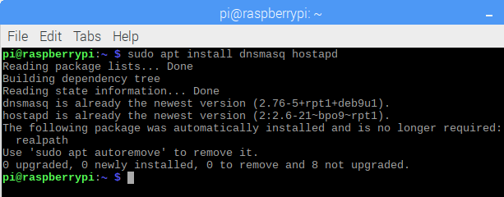>sudo apt install dnsmasq hostapd

>sudo systemctl stop dnsmasq

>sudo systemctl stop hostapd

## Configuring a static IP

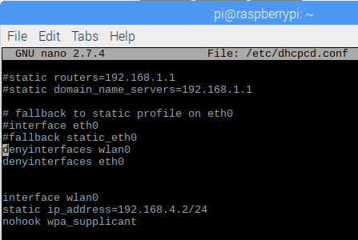>sudo nano /etc/dhcpcd.conf

>sudo service dhcpcd restart

## Configuring the DHCP server (dnsmasq)

>sudo mv /etc/dnsmasq.conf /etc/dnsmasq.conf.orig

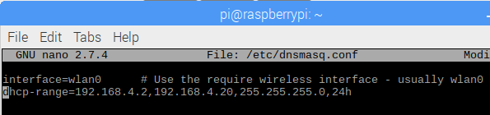>sudo nano /etc/dnsmasq.conf

>sudo systemctl reload dnsmasq

## Configuring the access point host software (hostapd)

>sudo nano /etc/hostapd/hostapd.conf

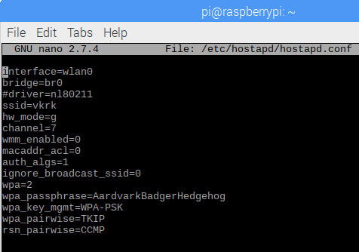

>sudo nano /etc/default/hostapd

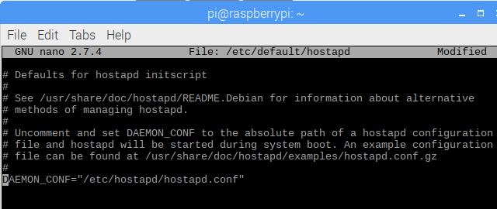Find the line with #DAEMON_CONF, and replace it with this

## Start it up

>sudo systemctl unmask hostapd

>sudo systemctl enable hostapd

>sudo systemctl start hostapd

>sudo systemctl status hostapd

>sudo systemctl status dnsmasq

# Using the Raspberry Pi as an access point to share an internet connection (bridge)

>sudo apt install hostapd bridge-utils

>sudo systemctl stop hostapd

>sudo nano /etc/dhcpcd.conf

Add denyinterfaces wlan0 and denyinterfaces eth0

>sudo nano /etc/systemd/network/bridge-br0.netdev

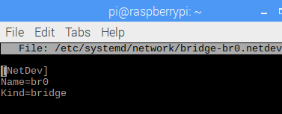

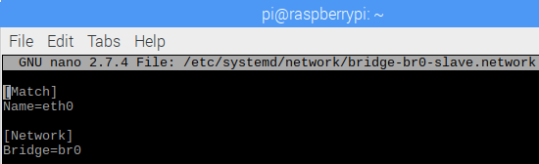>sudo nano /etc/systemd/network/bridge-br0-slave.network

>sudo nano /etc/systemd/network/bridge-br0.network

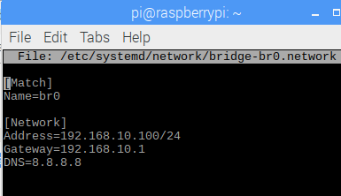

>sudo systemctl restart systemd-networkd

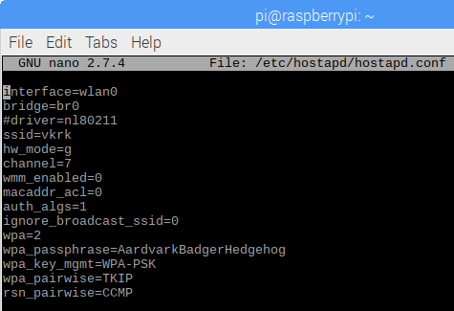>sudo nano /etc/hostapd/hostapd.conf

>sudo systemctl unmask hostapd

>sudo systemctl enable hostapd

>sudo systemctl start hostapd